Multimodal Manufacturing Creator

  - Course Name: Gen AI

Institution Name: Medicaps University – Datagami Skill Based Course

Student Name(s) & Enrolment Number(s):
Sr no | Student Name | Enrolment Number
1. | SRASHTI SEN | EN22CS301983
2. | SOUMYA SHRIVASTAVA | EN22CS301978
3. | TANISHKA RAGHUWANSHI | EN22CS3011019
4. | TARUN PATIDAR | EN22CS3011034
5. | VIDHI PRAJAPATI | EN22CS3011076

Group Name: Group 12
Project Number: 12
Industry Mentor Name: Mr. Yash
University Mentor Name: Prof. Vineeta Rathore
Academic Year: 2026

Problem Statement & Objectives

Problem Statement

Project Objectives

Scope of the Project

Proposed Solution
- Key features (Just mention key features here no need to go into details)
- Overall Architecture / Workflow
- Tools & Technologies Used (If applicable)

Results & Output
Add the below details here:
- Screenshots / outputs
- Reports / dashboards / models
- Key outcomes

Conclusion
Mention a brief conclusion about your project summing up everything you have worked on and the key learning.

Future Scope & Enhancements

1. Problem Statement & Objectives
1.1 Problem Statement
In modern manufacturing environments, effective visualization of product concepts and workflows is essential for design, communication, and decision-making. However, traditional approaches such as CAD tools, static diagrams, and textual descriptions often require significant expertise and time, and still fail to clearly represent complex ideas to all stakeholders.

These limitations create several challenges:
• Difficulty in understanding abstract manufacturing concepts
• Time-consuming manual design and visualization processes
• Limited accessibility for non-technical users
• Lack of real-time and interactive visualization tools

With the rise of Generative AI, it is now possible to automate both content generation and visualization. However, most existing solutions focus on either text generation (using LLMs) or image generation (using diffusion models) separately, lacking a unified system that combines both capabilities.

Therefore, there is a need for an integrated multimodal solution that can:
• Convert natural language manufacturing ideas into structured and detailed descriptions using LLMs
• Generate realistic and context-aware visual representations using diffusion-based image models
This project addresses the above challenges by developing a multimodal AI system that integrates Groq-powered LLMs and Stability AI image generation to deliver real-time, combined textual and visual outputs from a single user prompt.

1.2 Project Objectives
The primary objective of this project is to design and implement a multimodal Generative AI system that integrates text and image generation to enhance visualization of manufacturing concepts.
Specific Objectives:
• Develop an interactive system that accepts natural language prompts related to manufacturing concepts
• Utilize Large Language Models (LLaMA 3.1 via Groq) to generate structured and detailed product descriptions
• Integrate diffusion-based image generation (Stability AI) to create realistic and context-aware visual representations
• Combine textual and visual outputs into a unified multimodal response for better understanding
• Enable real-time generation of results using API-based architecture
• Improve conceptual learning, product visualization, and idea presentation in manufacturing domains
• Demonstrate the practical implementation of Generative AI technologies in real-world industrial and educational use cases
1.3 Scope of the Project
This project focuses on conceptual and educational visualization of manufacturing processes using a multimodal Generative AI approach. It enables users to generate both descriptive and visual outputs from a single input prompt, improving understanding and idea representation.

In Scope:
• AI-based concept generation using Large Language Models (Groq – LLaMA 3.1)
• Product prototype visualization using diffusion-based image generation (Stability AI)
• Multimodal output generation (text + image) from a single input
• User interaction through a simple web-based interface (Streamlit)

Out of Scope:
• Physical product manufacturing or real-world implementation
• Real-time industrial automation or hardware integration
2. Proposed Solution
2.1 Overview of the Solution
2. Proposed Solution
2.1 Overview of the Solution
The proposed system is a multimodal Generative AI application that integrates two key AI capabilities:
1. Text Generation (LLaMA 3.1 via Groq)
2. Image Generation (Stable Diffusion via Stability AI)
The system takes a single textual input from the user and produces:
• A detailed and structured product description using Groq-powered LLM
• A high-quality, photorealistic visual representation using Stability AI
Both outputs are generated in real-time through API-based integration and displayed via a web interface.
This dual output enhances understanding, improves communication, and enables users to effectively visualize manufacturing concepts without requiring advanced technical tools.

2.2 Key Features

1. Natural Language Input
Users can enter prompts such as:
• “Design a smart conveyor belt system”
• “Create a robotic arm for precision assembly”

The system accepts simple text input through an interactive Streamlit interface.

2. AI-Generated Concept Explanation
• Generates structured descriptions using LLaMA 3.1 (via Groq)
• Includes details such as:
o Functionality
o Components
o Working mechanism
o Use cases

3. Automated Image Generation
• Uses Stability AI to generate photorealistic images
• Produces visuals aligned with the input prompt
• Helps in visualizing product prototypes and manufacturing systems

4. Multimodal Output
• Combines text and image outputs into a single response
• Provides a complete and clear conceptual understanding

• Enhances both technical and non-technical communication

5. User-Friendly Interface
• Simple and interactive UI built using Streamlit
• Allows users to easily input prompts and view results
• Supports real-time generation and quick iteration

2.3 System Architecture / Workflow
Step-by-Step Workflow

Step 1: User Input
• The user enters a manufacturing-related prompt through the Streamlit interface

Step 2: Text Processing (LLM - Groq)
• The input is sent to LLaMA 3.1 model via Groq API
• The model generates:

o Detailed product description
o Key features and components
o Working mechanism and use cases

Step 3: Image Generation (Stability AI)
• The same prompt is sent to Stability AI API
• The model generates:
o Photorealistic product image
o Visual representation of the manufacturing concept

Step 4: Output Integration
• Text and image outputs are processed by the backend
• Both outputs are displayed together in the Streamlit UI

Step 5: User Interaction
• User can modify or refine the prompt
• System generates updated outputs in real-time

ARCHITECTURE DIAGRAM

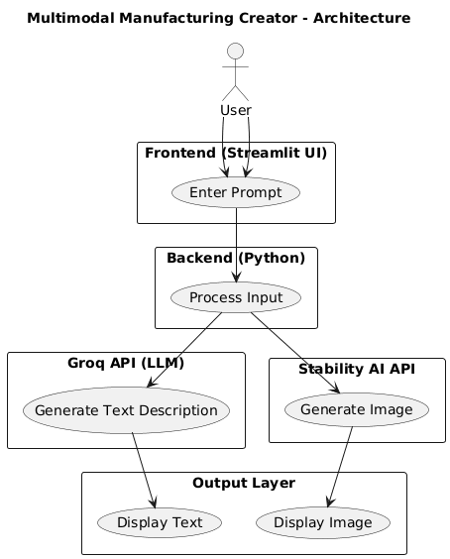

USE CASE DIAGRAM
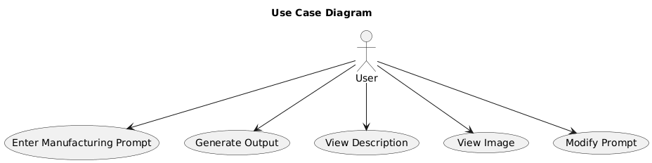

PROCESS FLOW DIAGRAM
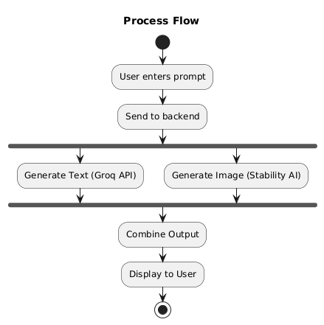

INFORMATION FLOW DIAGRAM
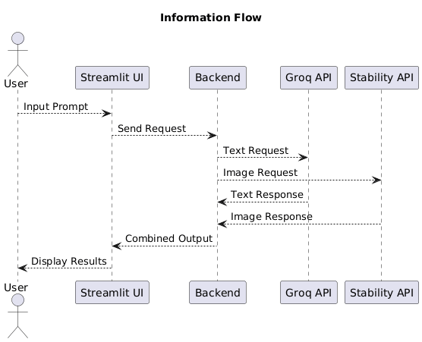

2.4 Tools & Technologies Used
Programming Language
• Python – Core development, API integration, and backend processing

AI Models
•LLaMA 3.1 (via Groq) – Large Language Model used for text generation, prompt understanding, and structured product descriptions
• Stable Diffusion (via Stability AI) – Diffusion-based model used for generating photorealistic images from textual input

APIs
• Groq API – Provides ultra-fast inference for LLaMA model to generate textual outputs
• Stability AI API – Used for generating high-quality, context-aware images from user prompts

Frontend
• Streamlit – Interactive web-based user interface for input and output display

Backend
• Python-based backend – Handles API calls, request processing, and data flow between components

Libraries Used
• requests – For handling API requests
• PIL (Python Imaging Library) – For image processing and manipulation
• streamlit – For building the UI

Additional Tools
• Prompt Engineering – For optimizing input queries to AI models
• REST API Integration – For seamless communication between services

- Results & Output

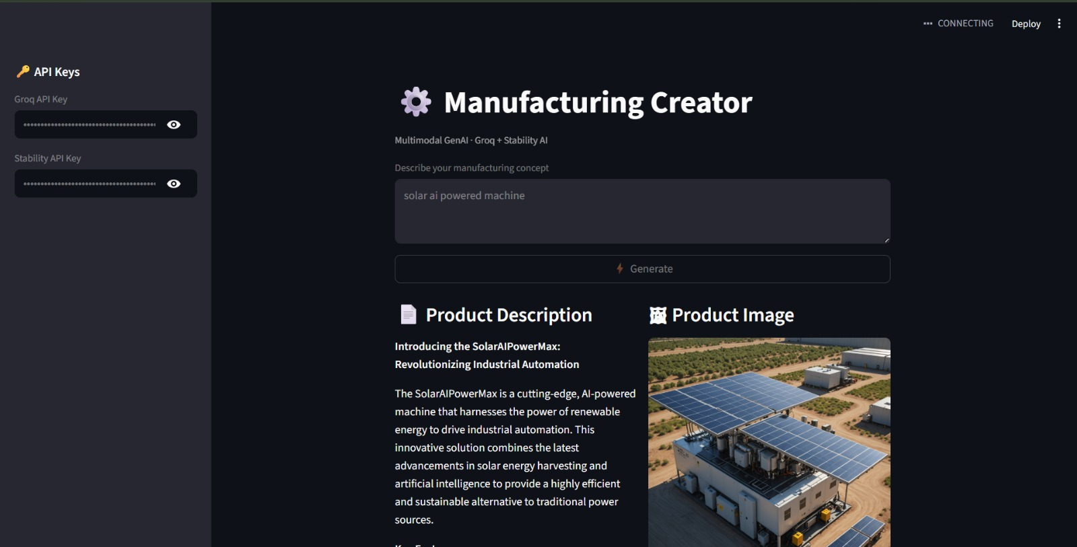
3.1 System Outputs
The system generates two types of outputs in real-time using a multimodal AI pipeline:
1. Text Output
• AI-generated detailed product description using LLaMA 3.1 (via Groq)
• Structured explanation including features, components, and working mechanism
• Clear and easy-to-understand content suitable for both technical and non-technical users
2. Image Output
• AI-generated photorealistic image using Stability AI
• Visual representation of the manufacturing concept or product prototype
• Context-aware image aligned with the user input prompt

3.2 Sample Output Example
- Input Prompt:
“Design an automated robotic arm for packaging”
Generated Text:
• Detailed description of the robotic arm system
• Key components such as sensors, actuators, and control units
• Working mechanism and operational flow
• Industrial applications and benefits
Generated Image:
• AI-generated realistic image of a robotic arm in a packaging environment
• Visual depiction of automation setup and industrial context

3.3 Key Outcomes
• Successfully implemented a multimodal AI system integrating text and image generation
• Demonstrated real-time API-based generation using Groq and Stability AI
• Improved understanding and visualization of complex manufacturing concepts
• Reduced dependency on traditional manual design and visualization tools
• Enabled faster idea generation and concept prototyping

4. Conclusion
This project successfully demonstrates the application of multimodal Generative AI in the field of manufacturing concept visualization. By integrating Large Language Models (LLaMA 3.1 via Groq) for text generation and diffusion-based models (Stability AI) for image generation, the system is able to produce both descriptive and visual outputs from a single user prompt.

The developed solution enhances understanding of complex manufacturing ideas by combining structured explanations with realistic visual representations. It simplifies the process of concept design and communication, making it accessible not only to technical users but also to non-technical stakeholders.

From a technical perspective, the project highlights effective API-based integration, real-time data processing, and prompt engineering techniques to achieve reliable and meaningful outputs. The use of Streamlit provides a simple yet interactive interface, ensuring ease of use and quick deployment.

Although the system has certain limitations, such as dependency on external APIs and lack of engineering-level precision, it successfully establishes a practical and scalable approach for AI-driven visualization.

Overall, the project showcases how multimodal AI can transform the way manufacturing ideas are generated, visualized, and communicated, and serves as a strong foundation for future advancements in AI-powered design and industrial applications.

5. Future Scope & Enhancements
1. 3D Model Generation
Extend the system to generate 3D product prototypes instead of only 2D images, enabling better visualization and design understanding.
2. Real-Time Simulation
Incorporate animation or simulation features to demonstrate how manufacturing processes or machines operate in real-time.
3. Improved Image Quality and Control
Integrate advanced diffusion models with better prompt control (e.g., style, angle, material) to generate more accurate and customizable visuals.
4. Voice Input Integration
Enable speech-to-text functionality to allow users to provide prompts using voice commands for enhanced usability.
5. Full-Scale Web Deployment
Deploy the system as a scalable web application using cloud platforms to support multiple users and real-time access.

